Steps to install pandas –
- Select your Python interpreter: Ctrl+Shift+P → Python: Select Interpreter.
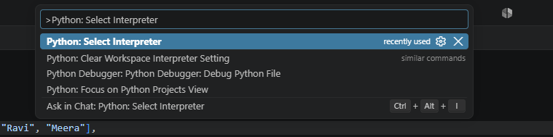
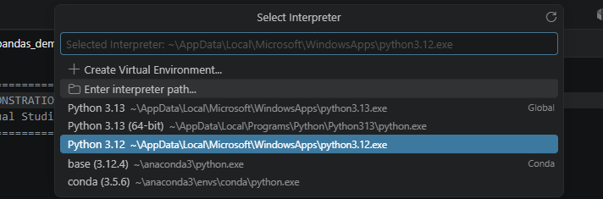
- In the VS Code terminal, install pandas if needed:
python -m pip install pandas
- Run the script:
python filename.py
You can also open the file and click Run Python File in the top right. If python isn’t recognized in the terminal, Python may need to be installed or added to PATH.

